DOCUMENT MODIFICATION TRACIBILITY
CREATOR |  |  |  |  | FOR APPROVAL
FILE | REV. | CREATOR | DATE | EVOLUTION DESCRPTION | NAME | FUNCTION | DATE | VISA
Work_Instruction_A17724Q_Op1_A.doc | A | Emman | 04/10/11 | Initial document | Magesh | Manuf. Engg. | 01/11/11
 |  |  |  |  | Fabien | Production | 01/11/11
 |  |  |  |  | Delphine | Quality | 01/11/11
Work_Instruction _A17724Q_ Op1_B.doc | B | Emman | 20/01/12 | Roughness changed on face and Ods  Tool 8 removed  Step hole removed  Visual check added on OD | Magesh | Manuf. Engg. | 07/02/12
 |  |  |  |  | Fabien | Production | 07/02/12
 |  |  |  |  | Delphine | Quality | 07/02/12
Work_Instruction _A17724Q _ Op1_C.doc | C | Emman | 28/05/12 | Machining strategy changed, Changes for new fixture, P/N A22573L added | Magesh | Manuf. Engg. | 28/05/12
 |  |  |  |  | Subramanian | Production | 28/05/12
 |  |  |  |  | Delphine | Quality | 28/05/12
Work_Instruction _A17724Q _ Op1_D.doc | D | Sivaraman S. | 21/03/13 | Machining strategy changed, Changes for new fixture, | Magesh | Manuf. Engg. | 22/03/13
 |  |  |  |  | Subramanian | Production | 22/03/13
 |  |  |  |  | Balasubramanian | Quality | 22/03/13
 |  |  |  |  | Magesh | Manuf. Engg. | 15/06/13
Work_Instruction _A17724Q _ Op1_E.doc | E | Sivaraman S. | 15/06/13 | Outer Diameter measuring gauge changed | Subramanian | Production | 15/06/13
 |  |  |  |  | Balasubramanian | Quality | 15/06/13

INPUT P/N | OUT PUT P/N | DESCRIPITON | VERSION
A18590G | A17724Q | GLACE-MS02-1C-CAST-NG | G
A18590G | A22573L | ME-GLACE-MSO2-1C-CAST-NG-A17724Q | B

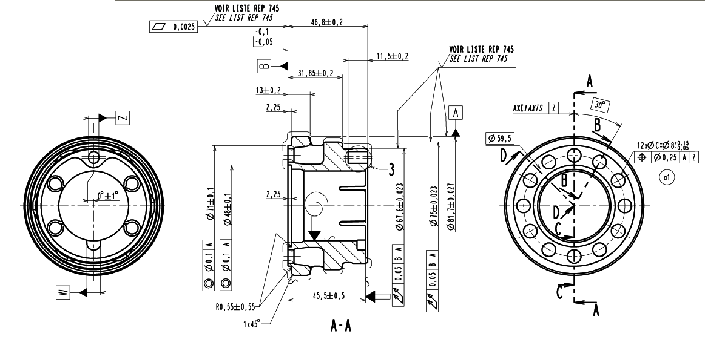
DRAWING1

- This section should have the drawing of the part with only selected dimensions

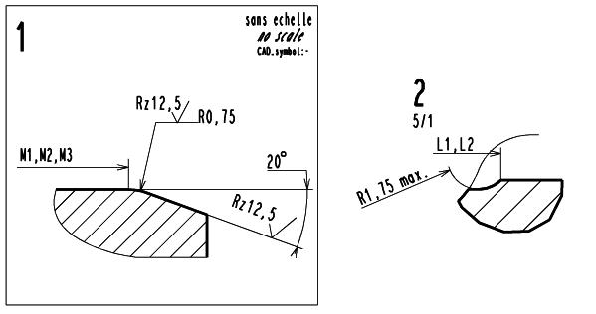
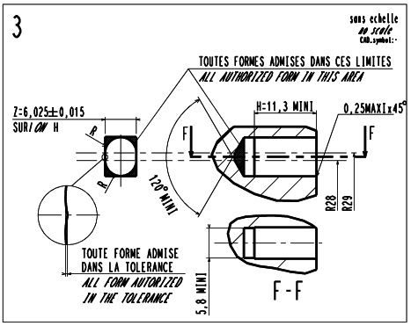

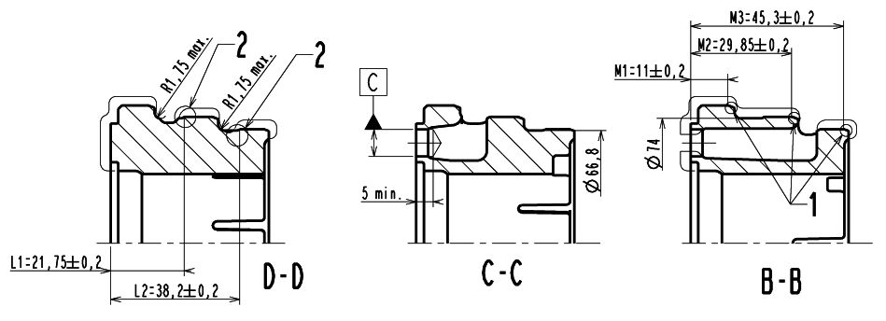

FIXTURE AND PROGRAM

FIXTURE DRAWING
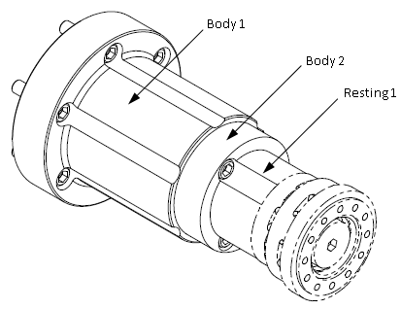

FIXTURE ASSEMBLY DESCRIPTION
FOR TMC 1

- Body 1 : MAIN BODY TMC 1
- Body 2 : 02 SUB BODY TMC1
- Resting 1 : A17724Q-OP1-RESTING1 TMC1
- Draw bar pressure : 0.7 Mpa
FOR TMC 2

- Body 1 : MAIN BODY TMC 2
- Body 2 : 02 SUB BODY TMC2
- Resting 1 : A17724Q-OP1-RESTING1 TMC2
- Draw bar pressure : 0.7 Mpa

PROGRAM NUMBERS
Main program: O1021
Sub Program: O0021
T0202
T0404

Part Loading-Orientation

TOOLS
X+
T0808
T1010

T0202
T0404

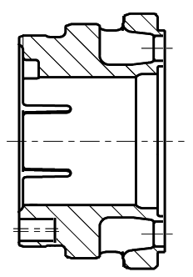
TOOLS PATH2
T0909

T0505

Z+

- This Section should show the work of each tool on the part

OPERATION SEQUENCE & TOOL LIFE
Operation Sequence No. | Operation Description | Tool Holder No.
N100 | Face rough facing | 02
N200 | Face finish facing | 04
N300 | ID finish turning | 05
N400 | Face milling | 09
N500 | OD rough back turning | 08
N600 | OD finish back turning | 10

TOOL LIST
TYPE OF TOOL | PSFT P/N | DESIGNATION | POSITION IN M/C | OFFSET | TOOL LENGTH | CONTINGENCY REFERENCES
Insert | - | CNMG120412-PM 4225 | 02 | 02 | N/A | CNMG120412 MR7 TP2500
Insert | - | WNMG060408-PM 4225 | 04 | 04 | N/A | WNMG060408 MF2 TP2500
Insert | - | WNMG060408-PM 4225 | 05 | 05 | N/A | WNMG060408 MF2 TP2500
Mill | - | 553080Z3.3-SIRON-A | 09 | 09 | 30.0mm mini | -
Insert | - | CNMG120412-PM 4225 | 08 | 08 | N/A | CNMG120412 MR7 TP2500
Insert | - | WNMG060408-PM 4225 | 10 | 10 | N/A | WNMG060408 MF2 TP2500

